CT077-3-2-DSTR DATA STRUCTURES
Lab 10: Queue
Part A: Queue Exercises
Name: Ian Chin Jun Sheng
Student ID: TP076218
Intake Code: APU2F2602CS (AI)

Question 1
// Lab 10 - Part A, Exercise 1 : sum of all elements in three linked list-based queues
#include <iostream>
using namespace std;

struct Node {
double data;
Node *next;
};

class linkedQueueType {
private:
Node *queueFront;
Node *queueRear;

public:
linkedQueueType() {
queueFront = NULL;
queueRear = NULL;
}

~linkedQueueType() {
while (!isEmpty())
dequeue();
}

bool isEmpty() {
return queueFront == NULL;
}

void enqueue(double value) {
Node *newNode = new Node;
newNode->data = value;
newNode->next = NULL;

if (isEmpty())
queueFront = newNode;
else
queueRear->next = newNode;
queueRear = newNode;
}

double dequeue() {
if (isEmpty()) {
cout << "Queue underflow! Nothing to dequeue." << endl;
return 0;
}
Node *temp = queueFront;
double value = temp->data;
queueFront = queueFront->next;
if (queueFront == NULL)
queueRear = NULL;
delete temp;
return value;
}

double sum() {
double total = 0;
Node *current = queueFront;
while (current != NULL) {
total += current->data;
current = current->next;
}
return total;
}
};

int main() {
linkedQueueType Q1, Q2, Q3;

Q1.enqueue(34.5); Q1.enqueue(22.5);
Q1.enqueue(44.5); Q2.enqueue(10.4);
Q2.enqueue(35.7); Q2.enqueue(38.7);
Q2.enqueue(19.7); Q3.enqueue(Q2.dequeue());
Q3.enqueue(Q2.dequeue()); Q3.enqueue(Q1.dequeue());
Q2.enqueue(66.7);
cout << Q1.sum() << ", " << Q2.sum() << ", " << Q3.sum() << "." << endl;

return 0;
}
Program output

Question 2
// Lab 10 - Part A, Exercise 2 : move the Nth element of a linked list-based queue to the front
#include <iostream>
using namespace std;

struct Node {
int data;
Node *next;
};

class linkedQueueType {
private:
Node *queueFront;
Node *queueRear;

public:
linkedQueueType() {
queueFront = NULL;
queueRear = NULL;
}

~linkedQueueType() {
while (!isEmpty())
dequeue();
}

bool isEmpty() {
return queueFront == NULL;
}

void enqueue(int value) {
Node *newNode = new Node;
newNode->data = value;
newNode->next = NULL;

if (isEmpty())
queueFront = newNode;
else
queueRear->next = newNode;
queueRear = newNode;
}

int dequeue() {
if (isEmpty()) {
cout << "Queue underflow! Nothing to dequeue." << endl;
return 0;
}
Node *temp = queueFront;
int value = temp->data;
queueFront = queueFront->next;
if (queueFront == NULL)
queueRear = NULL;
delete temp;
return value;
}

int size() {
int count = 0;
Node *current = queueFront;
while (current != NULL) {
count++;
current = current->next;
}
return count;
}

// pull the Nth element out, enqueue it, then rotate the others behind it
void moveNthFront(int n) {
int count = size();
if (n < 1 || n > count) {
cout << "Invalid N! Queue has " << count << " element(s)." << endl;
return;
}

// pass 1: cycle every element once, holding back the Nth one
int nthValue = 0;
for (int i = 1; i <= count; i++) {
int value = dequeue();
if (i == n)
nthValue = value;
else
enqueue(value);
}

// pass 2: Nth goes to the rear, then the rest cycle behind it
enqueue(nthValue);
for (int i = 1; i < count; i++)
enqueue(dequeue());
}

void display() {
cout << "{";
Node *current = queueFront;
while (current != NULL) {
cout << current->data;
if (current->next != NULL)
cout << ", ";
current = current->next;
}
cout << "}" << endl;
}
};

int main() {
linkedQueueType queue;
int values[] = {5, 11, 34, 67, 43, 55};
for (int i = 0; i < 6; i++)
queue.enqueue(values[i]);

int n;
cout << "queue = ";
queue.display();
cout << "Enter N: ";
cin >> n;

queue.moveNthFront(n);

cout << "After moveNthFront(" << n << "):" << endl;
cout << "queue = ";
queue.display();

return 0;
}
Program output
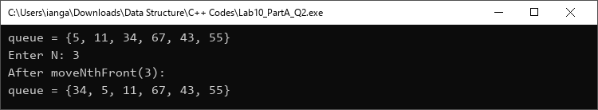

Question 3
// Lab 10 - Part A, Exercise 3 : palindrome check using an array-based queue and stack
#include <iostream>
#include <string>
#include <cctype>
using namespace std;

const int MAX_SIZE = 100;

struct Queue {
char items[MAX_SIZE];
int front;
int rear;
int count;
};

struct Stack {
char items[MAX_SIZE];
int top;
};

void enqueue(Queue &q, char value);
char dequeue(Queue &q);
void push(Stack &s, char value);
char pop(Stack &s);
bool isPalindrome(string text);

int main() {
string text;

cout << "Enter a line of text: ";
getline(cin, text);
cout << endl;

if (isPalindrome(text))
cout << "\"" << text << "\" is a palindrome." << endl;
else
cout << "\"" << text << "\" is not a palindrome." << endl;

return 0;
}

// circular array: rear wraps back to index 0 when it reaches the end
void enqueue(Queue &q, char value) {
q.rear = (q.rear + 1) % MAX_SIZE;
q.items[q.rear] = value;
q.count++;
}

char dequeue(Queue &q) {
char value = q.items[q.front];
q.front = (q.front + 1) % MAX_SIZE;
q.count--;
return value;
}

void push(Stack &s, char value) {
s.items[++s.top] = value;
}

char pop(Stack &s) {
return s.items[s.top--];
}

bool isPalindrome(string text) {
Queue q;
q.front = 0;
q.rear = MAX_SIZE - 1;
q.count = 0;

Stack s;
s.top = -1;

// keep letters and digits only, lowercased, in both structures
for (int i = 0; i < (int)text.length() && q.count < MAX_SIZE; i++) {
char ch = text[i];
if (isalnum(ch)) {
ch = tolower(ch);
enqueue(q, ch);
push(s, ch);
}
}

// queue gives letters forward, stack gives them backward
while (q.count > 0) {
if (dequeue(q) != pop(s))
return false;
}
return true;
}
Program output
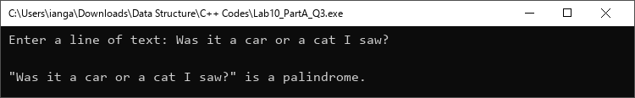
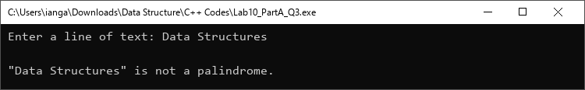

Question 4
// Lab 10 - Part A, Exercise 4 : clinic queue management system using a linked list-based queue
#include <iostream>
#include <string>
using namespace std;

struct Patient {
int number;
string name;
Patient *next;
};

Patient *queueFront = NULL;
Patient *queueRear = NULL;
int nextNumber = 1001;

void registerPatient();
void call();
void displayQueue();
bool isEmpty();

int main() {
int choice;

do {
cout << "===== Health Center Clinic QMS =====" << endl;
cout << "1. Register patient" << endl;
cout << "2. Call next patient" << endl;
cout << "3. Display queue" << endl;
cout << "4. Exit" << endl;
cout << "Enter choice: ";
if (!(cin >> choice))
break;
cin.ignore(1000, '\n');
cout << endl;

switch (choice) {
case 1: registerPatient(); break;
case 2: call(); break;
case 3: displayQueue(); break;
case 4: cout << "Exiting QMS." << endl; break;
default: cout << "Invalid choice!" << endl << endl;
}
} while (choice != 4);

// release any patients still waiting
while (!isEmpty()) {
Patient *temp = queueFront;
queueFront = queueFront->next;
delete temp;
}
return 0;
}

bool isEmpty() {
return queueFront == NULL;
}

// register is a C++ keyword, so the function is named registerPatient
void registerPatient() {
Patient *newPatient = new Patient;
cout << "Enter patient name: ";
getline(cin, newPatient->name);
newPatient->number = nextNumber++;
newPatient->next = NULL;

if (isEmpty())
queueFront = newPatient;
else
queueRear->next = newPatient;
queueRear = newPatient;

cout << newPatient->name << " registered. Queue number: " << newPatient->number << endl << endl;
}

void call() {
if (isEmpty()) {
cout << "No patient in the queue." << endl << endl;
return;
}
Patient *temp = queueFront;
cout << "Calling number " << temp->number << ", " << temp->name << ", please proceed for treatment." << endl << endl;

queueFront = queueFront->next;
if (queueFront == NULL)
queueRear = NULL;
delete temp;
}

void displayQueue() {
if (isEmpty()) {
cout << "No patient in the queue." << endl << endl;
return;
}
cout << "Remaining patients:" << endl;
Patient *current = queueFront;
int position = 1;
while (current != NULL) {
cout << position++ << ". [" << current->number << "] " << current->name << endl;
current = current->next;
}
cout << endl;
}
Program output


